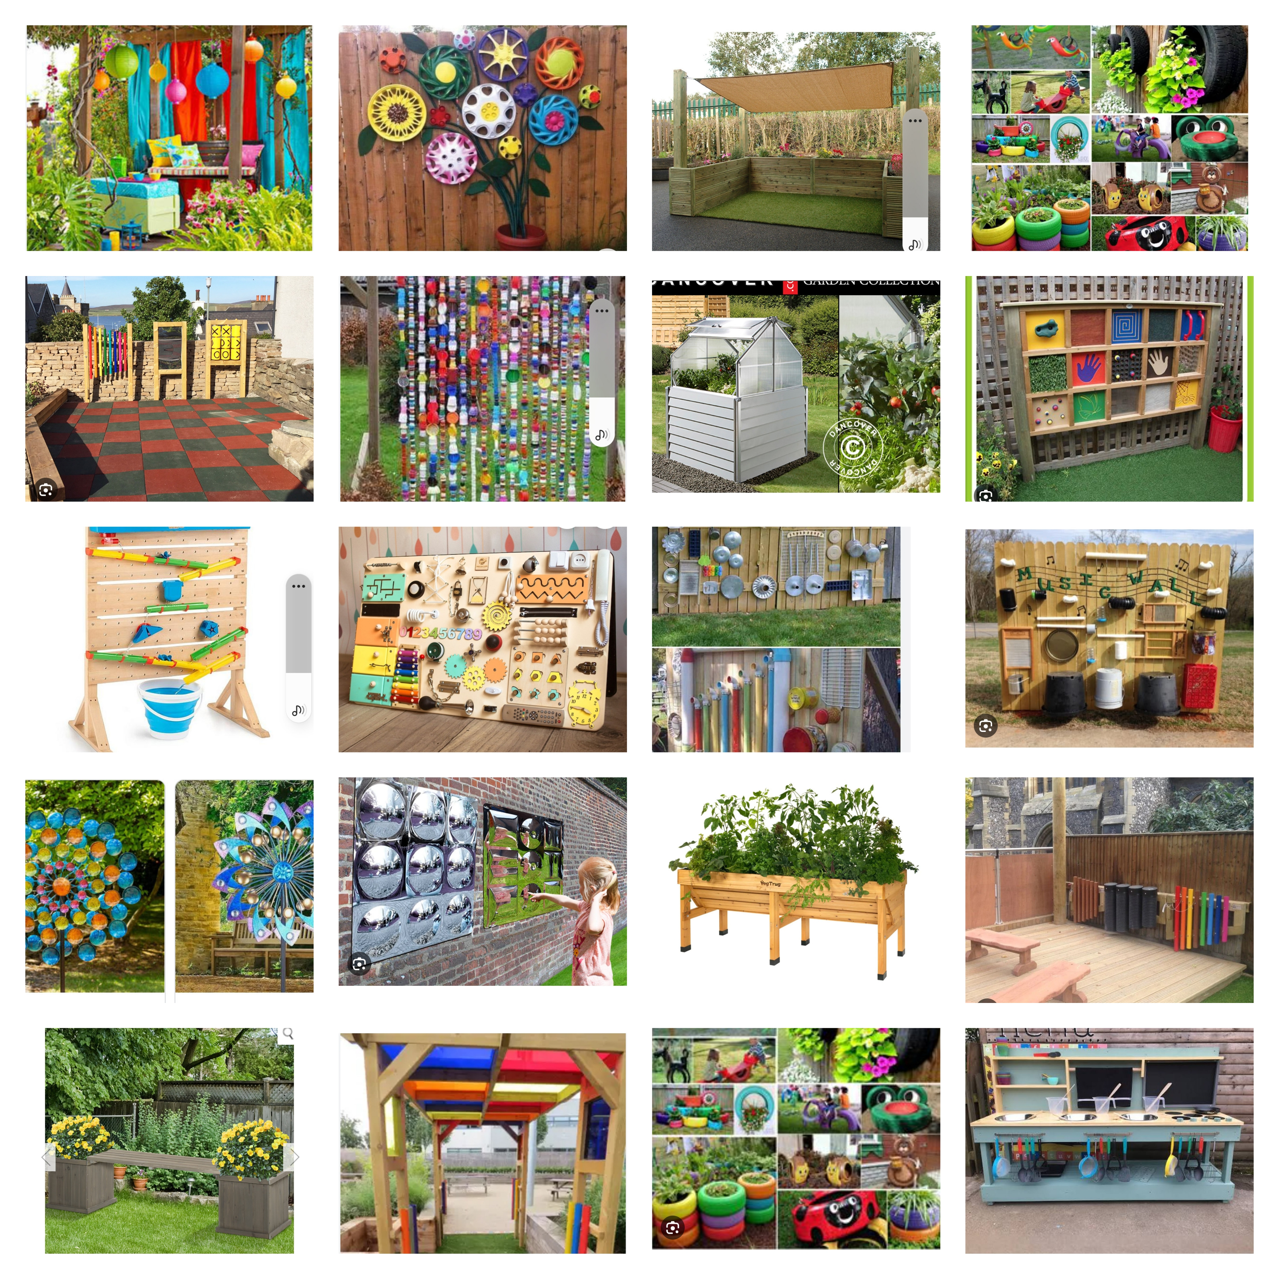

Sensory Garden Vision
Mill Ford School
Working In Collaboration
With
Mill Ford Friends Charity Ref 325090

Background

Mill Ford School is a special needs school for pupils with severe, profound and complex learning disabilities and difficulties, some of whom also have physical disabilities. They overcome many barriers in their lives and are an inspiration to all that meet them. Our pupils come from Plymouth, Devon and Cornwall.

Our funding comes from local authority, but Mill Ford Friends undertake a lot of fundraising to help purchase items that we cannot afford through the school budget. These funds, help and support the often-complex needs of our pupils in their learning, leisure, life skills and include physical and mental health.

We would like to install a sensory garden for our students, which would help in many areas including mental and physical health.

Why Do We Need A Sensory Garden?

A sensory garden will have many purposes of use for the students at the school, these include and are not limited to;

Sensory stimulation – Smell, Touch, Sound and Vision
Fine and Gross Motor Skills by using the sensory boards, instruments and taking care of the garden
Regulation Area – Reduce anxiety, distraction area and self-regulation
Learning – Learn how to grow and take care of plants, lifecycle of food from garden to plate – children will cook with the produce they grow
Recycling – Using water butts to collect rainwater for the plants, composting bin to reduce the waste from the school kitchen going to land fill. Using old and discarded plastic piping, car tyres and other items to make plant pots or instruments etc
Breakout area – Teachers to utilise the area for learning opportunities outside of class such as, science and music.

The school have a Student Eco Council, whose ethos is to reduce waste, recycle as much as possible, reduce carbon footprint and build a better environment for all.

What Principles Will We Follow?

Work directly with the students and school to ensure we incorporate as many items as possible to enrich lives on a daily basis
Sustainably source materials like wood from FSC regulated companies
Recycle discarded plastics and other materials to repurpose for a new use
Work with the students and wider community to bring our vision to life
Continue to Fundraise until our vision is attained

How Can You Help?

Mill Ford School currently has 121 students from Plymouth, Devon and Cornwall.
Due to the school being of a small size, fundraising for a project of this magnitude, can take a considerable amount of time and goodwill from the wider communities and businesses. In the last 12 months, Mill Ford Friends raised approximately £5000 and donated to many funding requests from the school for additional equipment not covered by the local authority funding.
Throughout the year Mill Ford Friends host cake sales, sponsored walks, and fayres to raise funds for the students at Mill Ford School.

This year a question was posed to the student council and parents/carers;

What would like Mill Ford friends to raise funds for next?
Overwhelmingly the answer was to build a sensory garden at the school.

Both parents/carers and students recognised the huge benefits of having a sensory garden at the school

Therefore, it was agreed the next project Mill Ford Friends would start to advance with, is the new sensory garden. We have been working on items we would like to have and location within the school ground – including size of site. A meeting with the Student Eco Council is due to take place soon, where they will be shown some of the ideas for the garden and will in turn be asked to discuss with their peers, what they would like and bring this to the next meeting with them.
Our aim is to start the project in early Spring 2024 and finish soon after.

Why Do We Need Your Help?

As previously mentioned, Mill Ford School is a small educational setting, and all children have some form of disability. Fundraising the large amounts of money required to complete this project will take a considerable amount of effort and time, which Mill Ford Friends are fully committed to. Not only is it the financial constraints but also the work force required to complete the project to a high standard. This standard is much higher than normal due to the complex needs and requirements of the students.
We need your help to achieve our goal and provide a sensory garden that matches the effort our students make each and every day. This could be a cash donation or donation of materials required

Mill Ford Friends will endeavour to complete as much work a possible themselves, however professional services will be required during the build.

